**WINDOWS FUNDAMENTALS 2**

**EX.NO:01 Date:12-02-2025**

**AIM:**

In part 2 of the Windows Fundamentals module, discover more about System Configuration, UAC Settings, Resource Monitoring, the Windows Registry and more.

**PROCEDRE:**

* Task 1 Introduction
* Task 2 System Configuration
* Task 3 Change UAC Settings
* Task 4 Computer Management
* Task 5 System Information
* Task 6 Resource Monitor
* Task 7 Command Prompt
* Task 8 Registry Editor
* Task 9 Conclusion

**TASKS:**

Task 1:

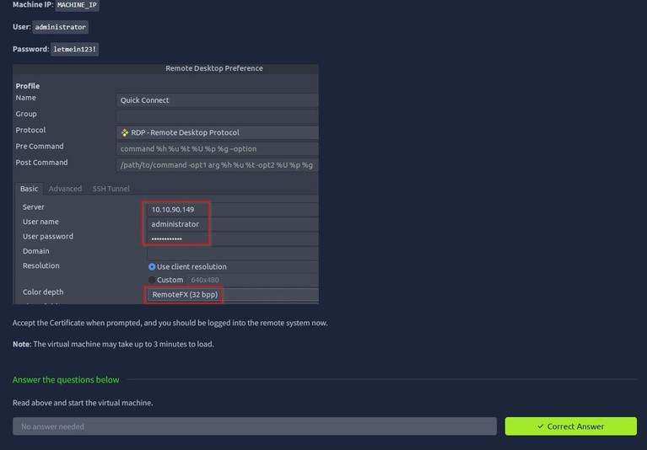

Task 2:

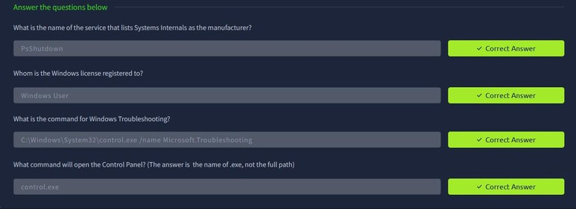

Task 3:

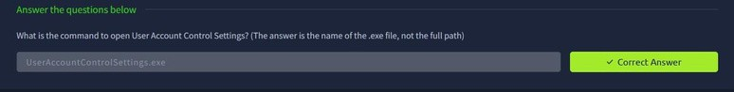

Task 4:

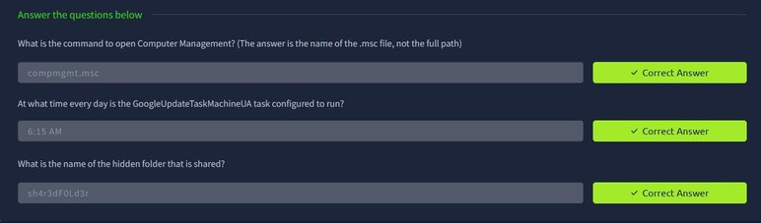

Task 5:

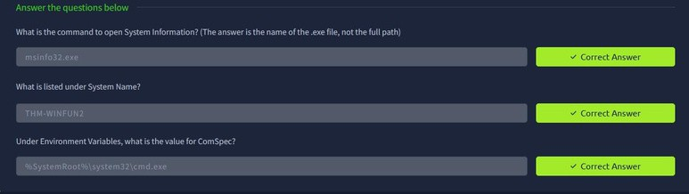

Task 6:

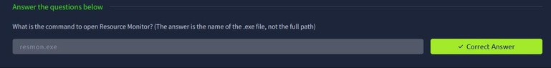

Task 7:

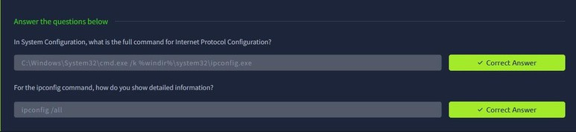

Task 8:

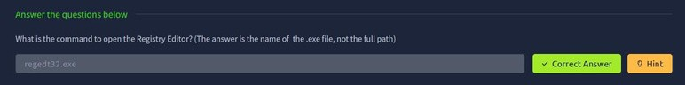

Task 9:

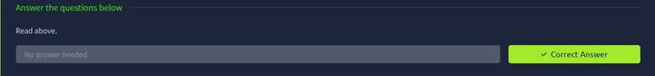

**RESULT:**

Thus the windows fundamentals 2 successfully completed in tryhackme platform.